- We think smaller once-a-year rises in regulated prices, a hefty drop in Ofgem's Q2 energy price cap, softer food price inflation, and the impact of policy measures from the 2025 Budget will combine to cause a sharp fall in UK inflation over the next few months. We expect these forces will pull headline inflation down to 2.1% by April.
- However, we expect inflation will drift up again slightly from H2 2026. Sticky pay growth is likely to prevent services inflation from returning to a target-consistent pace. Meanwhile, the drag on inflation in H1 from temporary Budget measures, including the decisions to remove some energy levies from household bills and to freeze rail fares, is likely to slowly unwind over time.
- Activity growth is weak and inflation is likely to remain slightly above the Bank of England's 2% target on a sustained basis, so the Monetary Policy Committee faces a challenging policymaking landscape. We expect this will limit the divided MPC to just two 25bp interest rate cuts in 2026.
After briefly returning to the Bank of England's 2% target in mid-2024, the UK experienced another burst of inflation last year. CPI inflation reached 3.8% in Q3 2025, having been boosted by a combination of large increases for a range of regulated and index-linked prices, high food price inflation, and the passthrough of April 2025's rises in employers' national insurance contributions and the national living wage.
However, inflation has cooled since then, and many of the same factors that pushed the headline rate higher last year are set to unwind in H1 2026. Therefore, we expect CPI inflation to fall sharply over the coming months, reaching 2.1% in April (Chart 1). Our key consideration is the durability of this downward pressure. We suspect inflation will settle slightly above the 2% target in H2 2026 and 2027. If we're right, this will have important implications for the timing and pace of interest rate cuts this year, as well as the outlook for real household income growth and consumer spending.
Chart 1: We expect inflation to temporarily return very close to the BoE's 2% target in Q2 2026
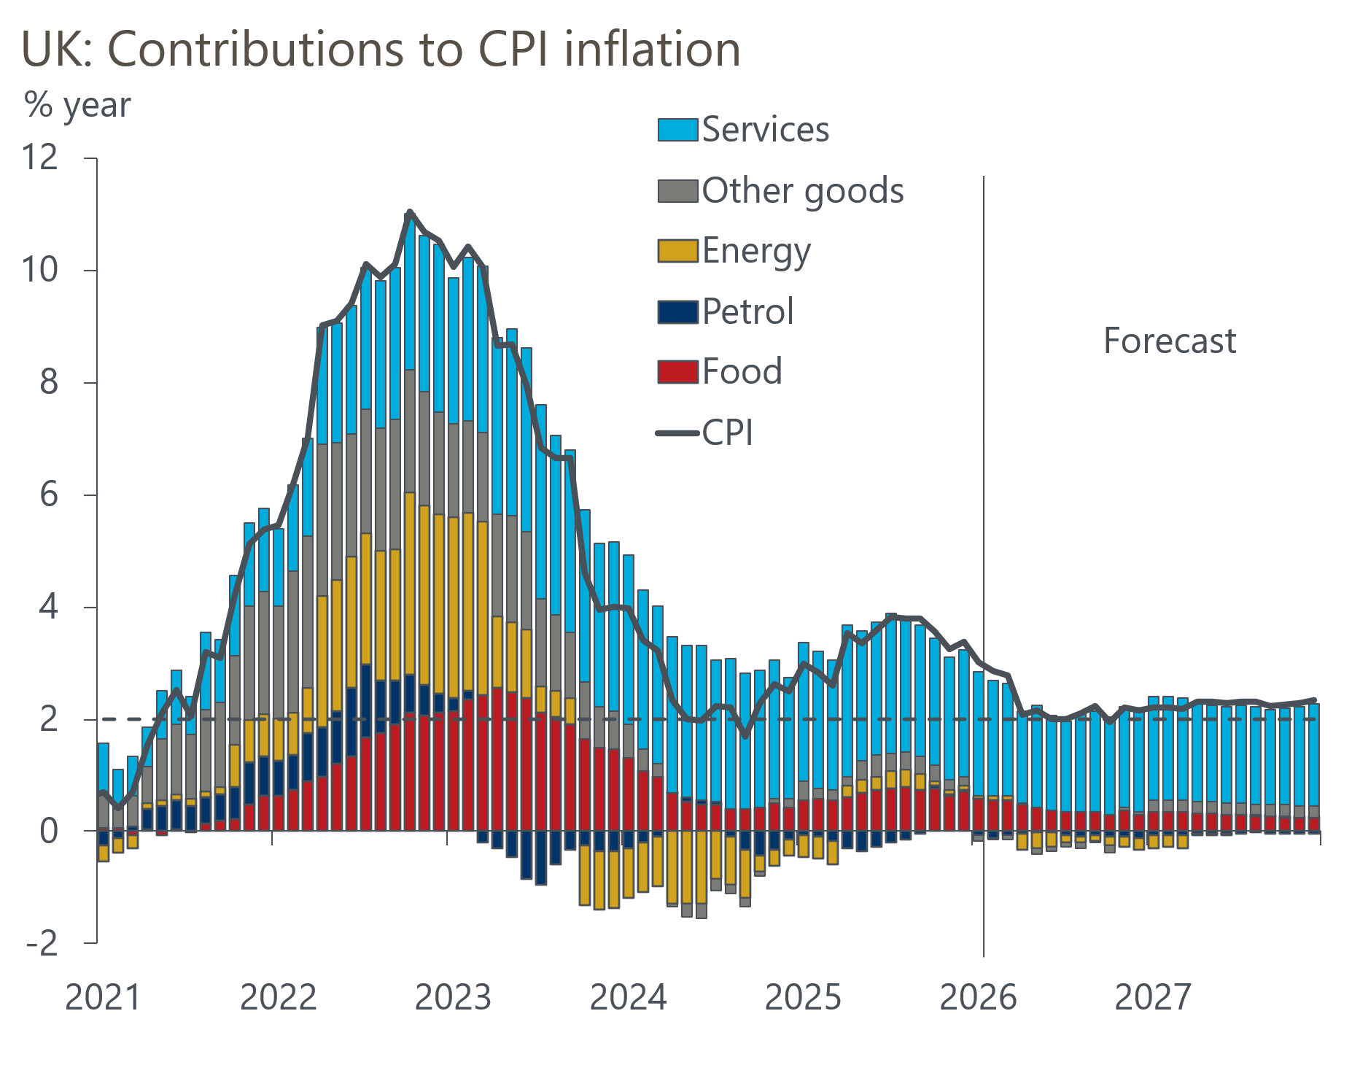
Source: Oxford Economics modelling using Haver Analytics

Energy and other regulated prices will be the key drivers of lower inflation
Two main factors are likely to weigh heavily on inflation in H1 2026. The first and most significant is much smaller once-a-year price increases in the part of core inflation where prices are regulated or index-linked. Water bills are set to rise by an average 5.4% from April, which is well shy of the bumper 26% hike last year. The government's decision to freeze rail fares will add to the downward pressure. Meanwhile, the contribution from the vehicle excise duty sub-category should fall significantly, as last year's removal of the electric vehicle exemption won't be repeated.
Index-linked contracts and regulated prices collectively account for about 14% of core inflation, so they play a major role in driving the annual inflation story. But for the components where annual changes aren't explicitly announced, price increases are notoriously difficult to predict. Indeed, forecast errors for headline and core inflation in April – the month where most of these prices reset – from consensus surveys have been very high in recent years, and well above the prediction errors seen in other months (Chart 2).
Chart 2: Regulated price increases have resulted in large April consensus forecast misses in recent years
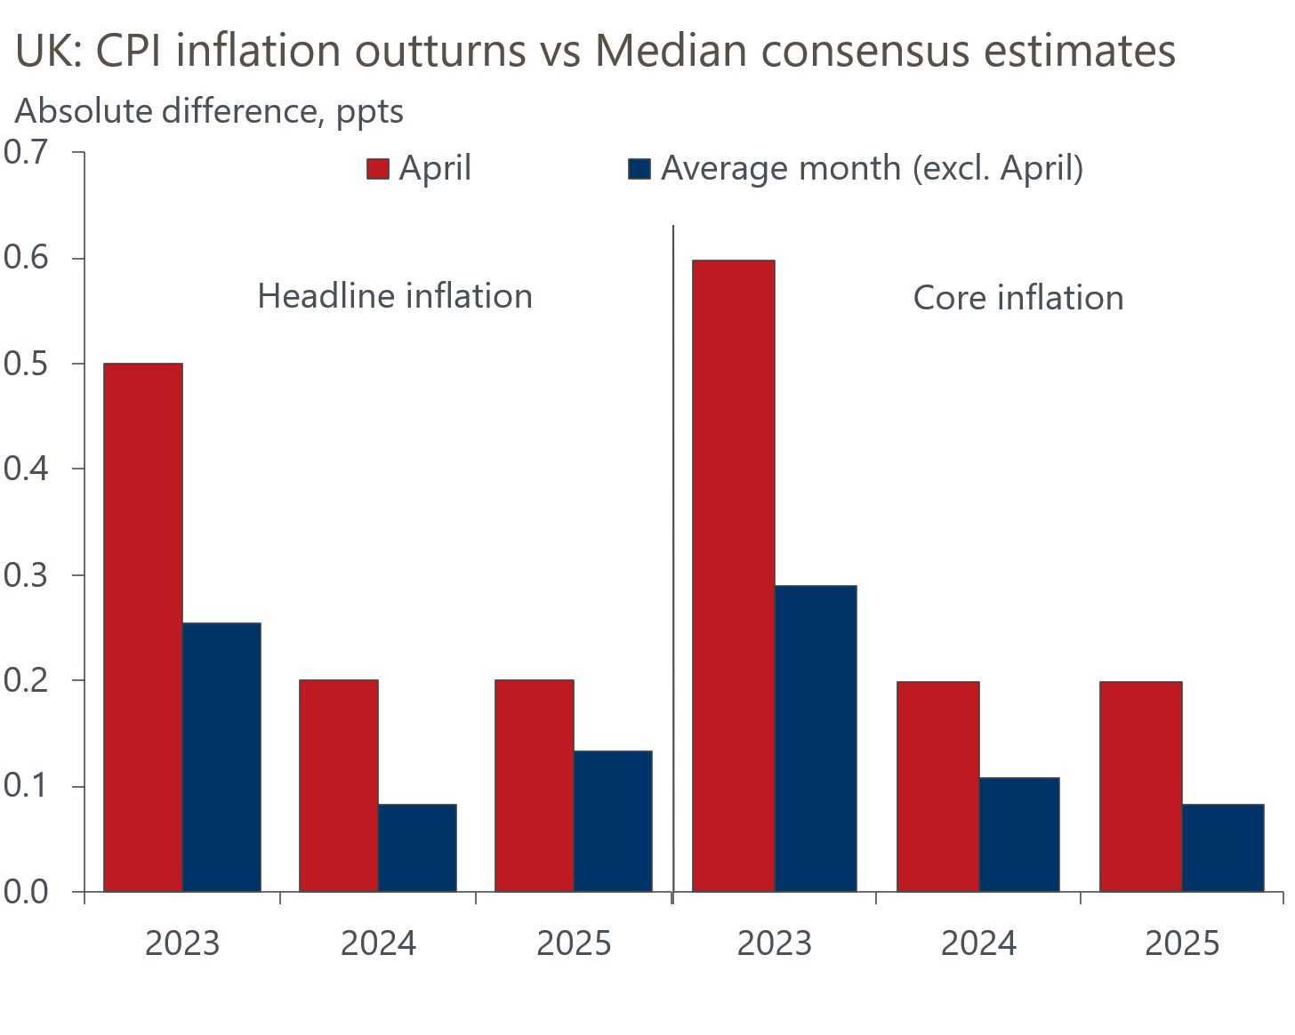
Sources: Haver Analytics, Bloomberg
What's more, some index-linked prices, such as for new internet and phone contracts, will now fall under the government's 'pounds and pence' pricing system. This requires providers to explicitly state mid-contract price rises as a fixed monetary value (e.g. +£4/month), rather than as percentage increases tied to inflation. However, the new system creates a further layer of uncertainty for forecasters, given the range of deals available to customers. The early evidence also suggests that the new system is generating much larger annual price rises, particularly for customers on cheaper starting tariffs.
Nevertheless, we still expect smaller increases overall for index-linked and regulated prices than were seen last year. This should bake in weaker core inflation from the spring for the following twelve months.
The second factor is that Ofgem's latest price cap announcement revealed that household energy bills will fall materially from April. This is due in part to the government's decision to scrap the Energy Company Obligation and fund 75% of Renewable Obligation costs from general taxation rather than household bills over the next three years. But it also reflects the impact of lower wholesale gas futures prices; in the latest Ofgem observation window prices fell 5.5%, and they were 9% below the level of the previous window. As a result, the price cap will fall by 6.7% in April (Chart 3). This should see the contribution to CPI inflation from the energy category turn negative and fall by almost 0.4ppts in April.
Chart 3: Ofgem's energy price cap is set to fall in April due to policy changes and lower wholesale prices
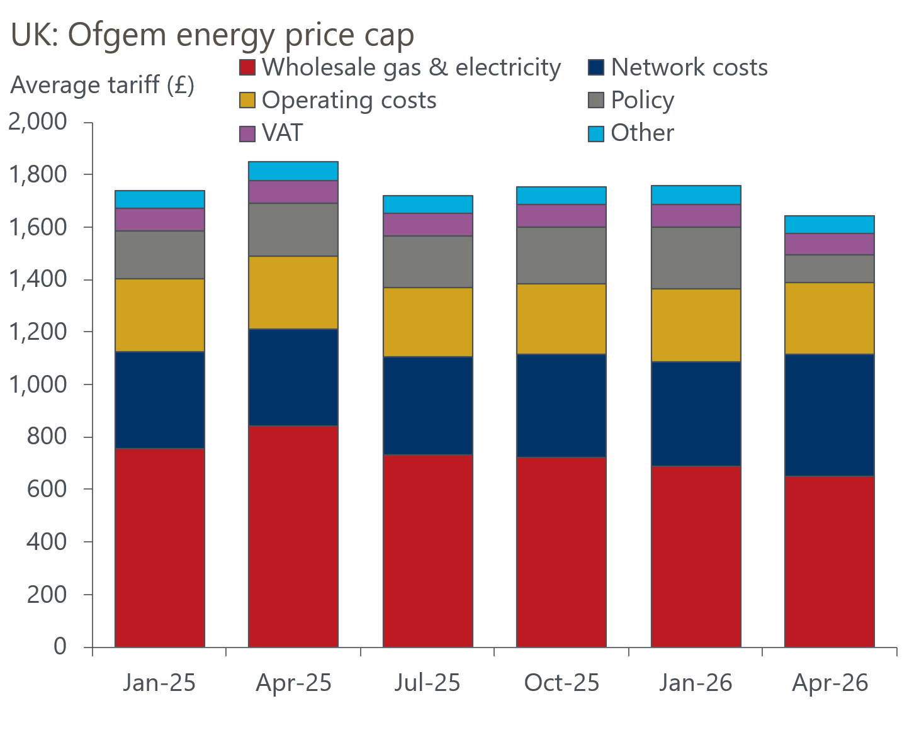
Sources: Ofgem
A broad-based cooling in other categories is expected to account for the remaining fall in CPI inflation through H1 2026. Food price inflation is likely to weaken further, with key agricultural commodity prices declining and the BoE's Agents reporting that additional domestic producer costs associated with regulatory changes last year have already largely passed through to consumer prices. Meanwhile, services inflation is likely to experience some additional downward pressure, beyond the impact of smaller regulatory price rises, from softer pay growth, the fading impulse from the April 2025 increase in employers' national insurance contributions, and a smaller 2026 national living wage rise.

But underlying inflationary pressures are likely to remain relatively sticky
We think there's a good chance that inflation will start to creep up again slightly from H2 2026. Given that labour costs account for a large proportion of a firm's cost base, the outlook for pay growth will be key to how underlying services inflation evolves.
Using an approach set out in Yellen (2017) and recent BoE Monetary Policy Reports to forecast pay growth based on its key structural determinants, our modelling suggests that most of the large decline in pay growth is now behind us. Further downward pressure across H2 2026 and early 2027 is expected to be more modest, as inflation expectations only normalise slowly and the degree of slack in the economy remains relatively steady (Chart 4).
Chart 4: Our projections of the key drivers of pay growth point to more limited scope for further cooling
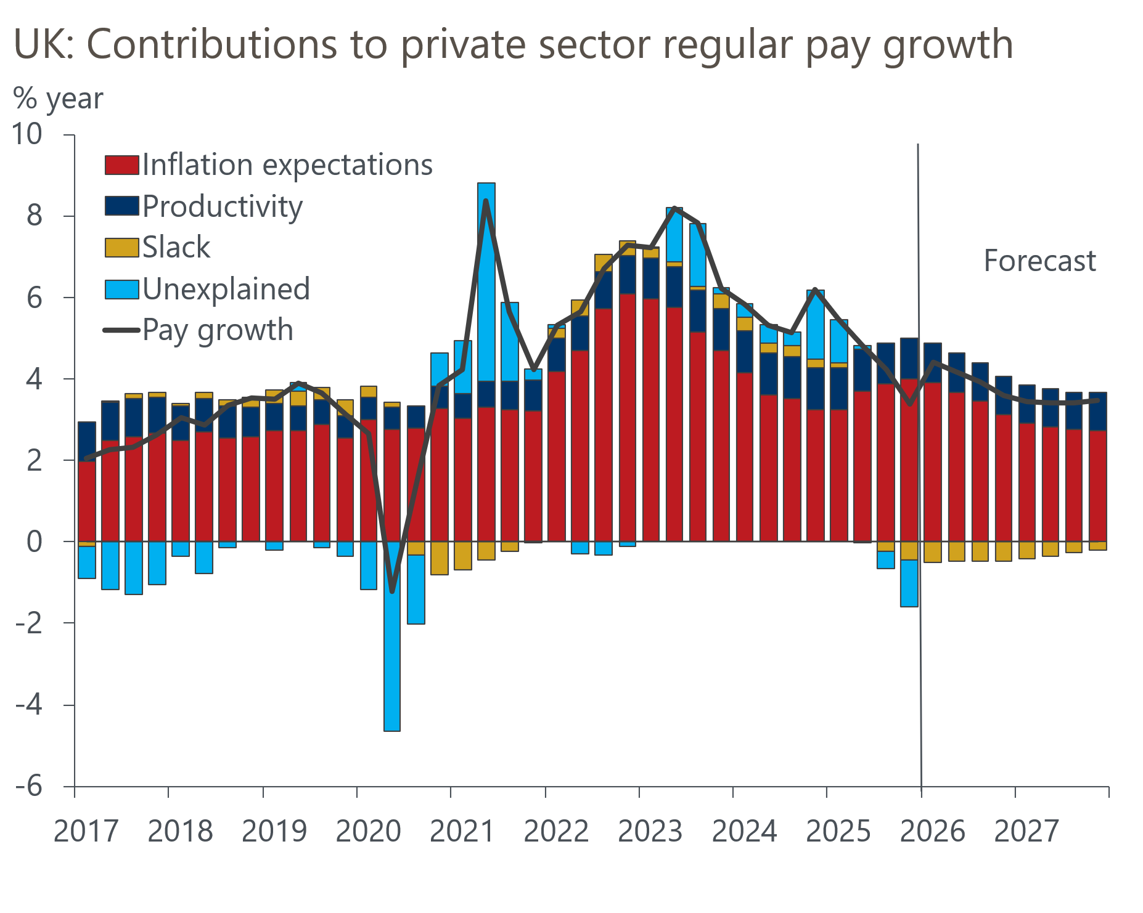
Sources: Oxford Economics modelling using Haver Analytics
Meanwhile, other forward-looking indicators also suggest that pay growth is likely to remain slightly above the 3.25% level that the BoE estimates would be consistent with meeting its 2% inflation target in the medium term. The BoE's Decision Maker Panel reports that year-ahead wage growth expectations have stabilised around 3.6%-3.8% for the best part of a year now. The BoE's 2026 Agents pay survey showed that the average expected settlement over the next year is 3.4%, only slightly lower than the reported outturn for 2025.
We think sticky pay growth will probably keep underlying services inflation from returning to a target-consistent pace over the next year. If this materialises, usually soft readings in the other main inflation categories would be required for inflation to remain at the 2% target through H2 2026 and into 2027.
We view the chances of such an outcome as relatively low. Some chunky base effects in the core goods category are set to push inflation higher towards the end of this year. Similarly, the downward pressure from measures announced at the 2025 Budget, such as the decision to temporarily remove some energy levies from household bills and to freeze rail fares, should unwind in early 2027. Meanwhile, the Chancellor also plans to increase fuel duty. Our forecast factors in the 1p per litre duty increase set to take effect from September 2026, as there shouldn't be another fiscal event before then. Given the long track record of Chancellors backing out of fuel duty increases, we haven't incorporated the additional 2p rises in December 2026 and March 2027 that were announced in the 2025 Budget. But if the Chancellor also follows through on these increases, it would add to the upward pressures on inflation next year.
As a result, we expect headline inflation to settle a little higher than the 2% target in H2 2026 and 2027.

Lower inflation is unlikely to be a game changer for growth and monetary policy
The momentum behind real household income growth has already started to slow, and we expect this to continue over the next couple of years. Even though the picture for inflation now looks a bit more benign than it did previously, a larger decline in pay growth means real wage growth is still likely to slow quite sharply over this period. What's more, policy settings will also weigh on income growth, with the ongoing freeze in most allowances and thresholds ensuring that income tax and national insurance payments continue to rise strongly. On the monetary side, though we anticipate further cuts to Bank Rate, net interest income will increasingly drag on household incomes in the near term. These conditions should keep consumer spending growth around 1% this year and in 2027.
Subdued growth in consumer spending is a key tenet of our forecast for GDP growth to remain a little below trend over the next couple of years. The prospect that economic activity growth continues to underwhelm, during a period where we expect CPI inflation to be slightly above the 2% target, creates a tricky balancing act for the BoE's Monetary Policy Committee to manage.
It's clear that a majority of MPC members anticipate that further cuts to Bank Rate will be required. But the committee remains very divided on the scale and pace at which rates will be lowered. Against this backdrop, we think lingering inflationary pressures will encourage the more marginal voters on the committee to maintain a cautious approach to loosening policy and to set policy at a level that continues to restrain activity growth to a sluggish pace.
As a result, further easing is likely to be gradual. Our forecast sees two 25bp cuts to Bank Rate in 2026, with the first coming in March or April, and the second in November. This is broadly in line with current financial market pricing, and would take Bank Rate down to 3.25% at the end of this year.

